ADVENTURE WORKS · TECHNICAL SUPPORT

Flat Tire Repair and Tube Replacement
Wheels & Tires Document TS-005 Rev. A
Applies to | All Adventure Works models (tubed tires)
Difficulty | Beginner
Time required | 15 – 25 minutes
Tools needed | Tire levers, Spare tube or patch kit, Pump with gauge, 15 mm wrench (non-QR axles)

Symptoms
- Tire is soft or completely flat.
- The bike feels squirmy or the rim 'clunks' over bumps.
- Air added the day before is gone by morning.
- A visible object (thorn, glass, staple) is lodged in the tread.
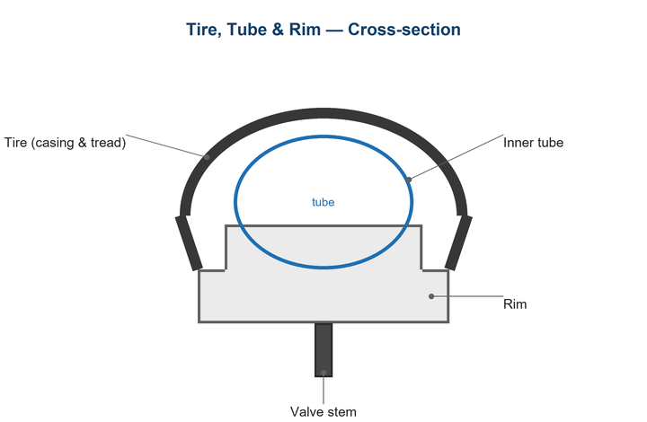
Figure 1. Tire, tube, rim, and valve in cross-section.

Likely Causes
- Puncture from road or trail debris.
- Pinch flat ('snakebite') from hitting an edge at low pressure.
- A failed or aged valve.
- A worn tire casing or a protruding spoke end inside the rim.
- Rim tape that has shifted and exposed a spoke hole.
Safety first
- Fully deflate the tube before removing it to avoid sudden pops.
- Inflate to the pressure printed on the tire sidewall — never exceed the maximum.
- Check the rim and tire for the cause before fitting a new tube, or it will fail again.

Customer Fix — Step by Step
Suitable for home repair with basic tools. Work through the steps in order.
- Release the brake (if rim brake) and remove the wheel using the quick-release or axle.
- Deflate fully, then use tire levers to unseat one bead and pull the tube out.
- Run your fingers carefully inside the tire and along the rim to find the cause — remove any thorn, glass, or burr.
- Confirm the rim tape covers all spoke holes and sits centered.
- Lightly inflate the new tube so it holds shape, tuck it inside the tire, and seat the valve straight.
- Work the bead back on by hand (avoid pinching the tube with levers), inflate to the sidewall pressure, and check the bead is seated evenly all around.
- Refit the wheel, re-engage the brake, and confirm it spins true and the axle is tight.

Technician Reference
Additional checks and adjustments for service technicians and advanced users.
- For a patch repair, inflate the tube and locate the leak by sound or by dunking in water; mark it.
- Buff the area, apply a thin even layer of vulcanizing cement, wait until tacky, then press the patch firmly for 60 seconds.
- Inspect the casing for cuts >3 mm; boot the tire or replace it if the casing is compromised.
- Verify rim strip width and condition; replace if cracked or mispositioned.
- Set pressure for rider weight and tire width (lower for wide/tubeless, higher for narrow road).

Torque & Specifications
Setting | Typical value
Road 25–28 mm | 70 – 90 psi
Gravel 38–45 mm | 35 – 50 psi
MTB 2.2–2.5" | 22 – 30 psi
City/hybrid 35–42 mm | 50 – 70 psi
Always | Stay at or below sidewall max

Figure 2. Seat the valve straight and check the bead is even before full inflation.
Pro tips
- Carry a spare tube even if you also patch — it's faster on the road.
- Mark the tire position relative to the valve so a found object points you to the casing hole.

When to Visit a Service Center
- Repeated flats with no obvious cause (possible rim or alignment fault).
- The tire casing is cut, frayed, or showing cords.
- A tubeless tire won't seal or seat on the rim.
- The rim is dented or cracked at the bead.
This guide is provided for reference. Torque values are typical starting points — always follow the specific component manufacturer's instructions. © Adventure Works.

